DAY 2 MINI PROJECT
ENTERPRISE PUBLIC VS PRIVATE IP ADDRESS ANALYSIS

📌 Project Objective
The objective of this project is to analyze public and private IP addresses, understand NAT communication, and explore how organizations use IP-based security controls in enterprise IAM environments.
This project also demonstrates practical networking analysis using real-world troubleshooting and IAM security concepts.

🌐 Introduction
Every device connected to a network requires an IP address for communication.
IP addresses are categorized into:
- Public IP Address
- Private IP Address
Understanding these concepts is essential in:
- Networking
- Cybersecurity
- Cloud Security
- Identity & Access Management (IAM)

🔒 Private IP Address Analysis
My Private IP Address
My private IP
10.221.64.26

Explanation
A private IP address is used inside local/internal networks.
Private IP addresses:
- Are not directly visible on the internet
- Are assigned internally by routers
- Help organizations securely manage internal communication

🌍 Private IP Ranges
10.0.0.0 – 10.255.255.255
172.16.0.0 – 172.31.255.255
192.168.0.0 – 192.168.255.255

🌐 Public IP Address Analysis
My Public IP Address
My public IP)
Example:
106.192.36.233

ISP Information
My ISP name is:
Bharti Airtel Ltd.

Explanation
A public IP address is internet-visible and assigned by the Internet Service Provider (ISP).
Public IP addresses allow communication between local networks and the internet.

🔄 NAT (Network Address Translation)
NAT converts:
Private IP → Public IP
Example:
10.221.64.26
↓
106.192.36.233

📌 Why NAT Is Important
NAT helps:
- Save IPv4 addresses
- Improve security
- Hide internal devices
- Allow internet communication

🌐 Network Communication Flow
Laptop
↓
Private IP
↓
Router/Gateway
↓
NAT Translation
↓
Public IP
↓
ISP
↓
Internet

🧠 DNS Analysis
DNS (Domain Name System) converts domain names into IP addresses.
Example:
google.com → IP address
This helps users access websites using names instead of numerical IP addresses.

🛠 Commands Used
ipconfig
ping google.com
nslookup google.com

📌 Ping Analysis
The ping command was used to:
- Test internet connectivity
- Measure response time
- Verify communication with external servers

📌 DNS Lookup Analysis
The nslookup command was used to:
- Analyze DNS resolution
- Convert domain names into IP addresses

🔐 IAM Security Mapping
Organizations use IP addresses in IAM systems for:
- Conditional Access
- Geo-location tracking
- MFA triggering
- Suspicious login detection
- VPN restrictions
- Risk-based authentication

🎯 Enterprise Scenario Analysis
Scenario
An employee usually logs in from India.
Suddenly, a login attempt occurs from another country using an unknown public IP address.

IAM Security Response
IAM systems may:
- Trigger Multi-Factor Authentication (MFA)
- Block the login
- Alert security teams
- Mark login as risky
- Apply conditional access policies

🔥 Zero Trust Security Concept
Modern organizations follow:
“Never Trust, Always Verify”
Even if login comes from a valid IP:
- Identity verification is still required
- Device trust is validated
- Risk analysis is performed

🛡 Firewall & Security Controls
Organizations use firewalls to:
- Allow trusted IP addresses
- Block suspicious IP addresses
- Restrict traffic from risky countries
- Monitor network communication

📊 Public IP vs Private IP Comparison
Public IP | Private IP
Visible on internet | Used inside local network
Assigned by ISP | Assigned by router
Globally unique | Internal use
Used for internet communication | Used for internal communication
📸 Screenshots Included
- Private IP (ipconfig)
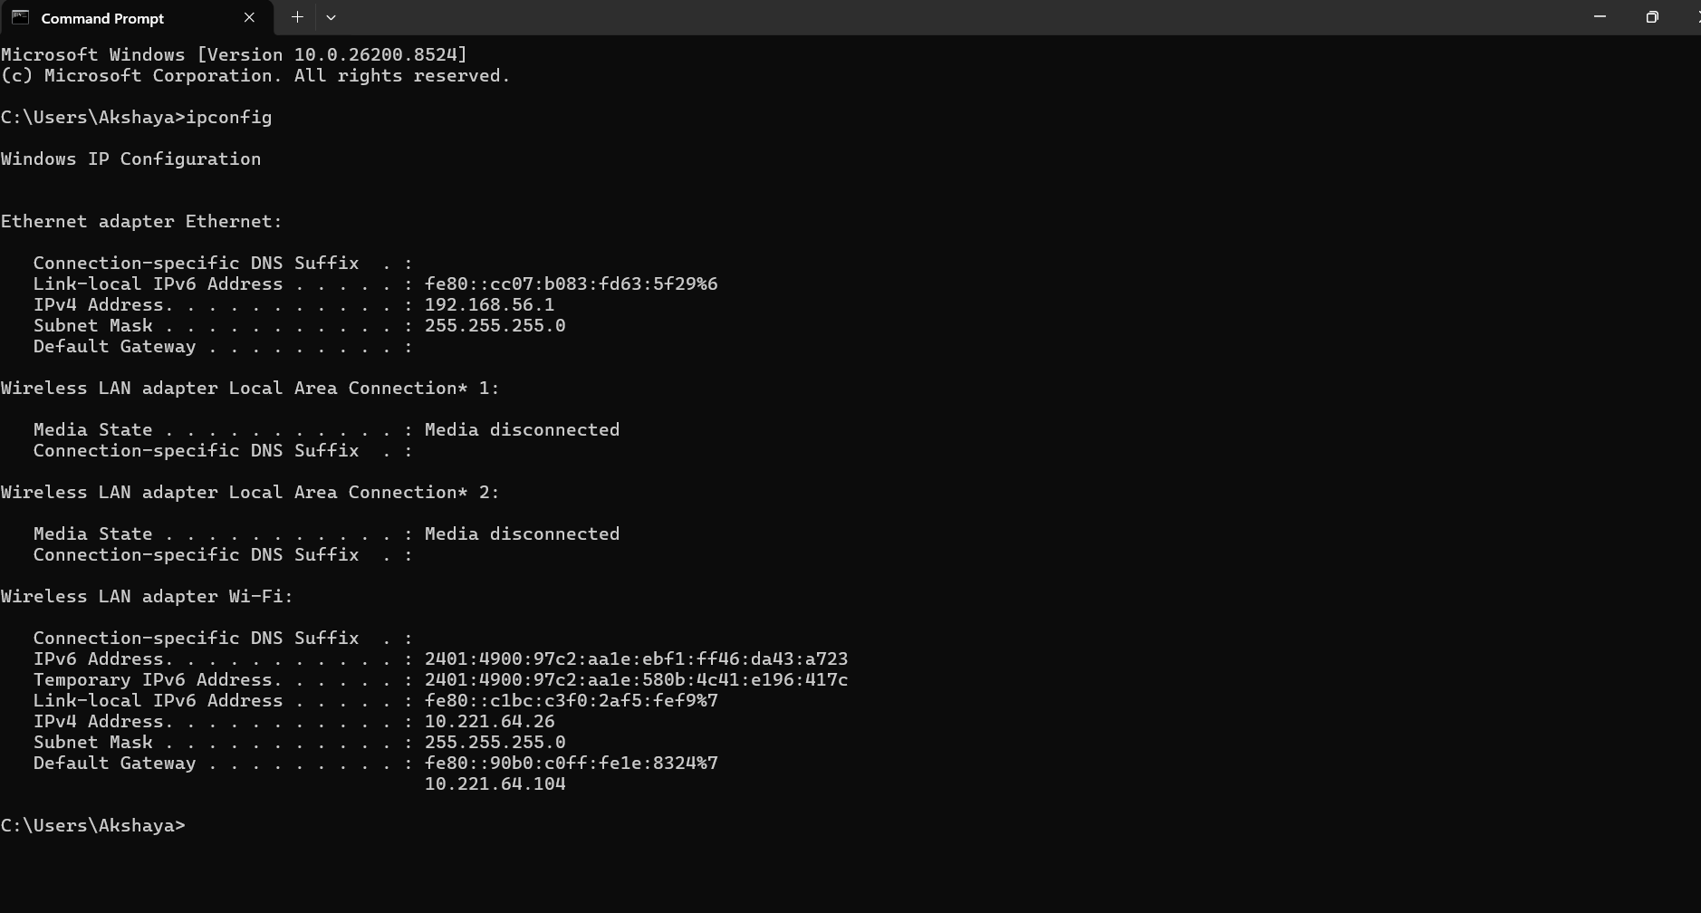

- Public IP lookup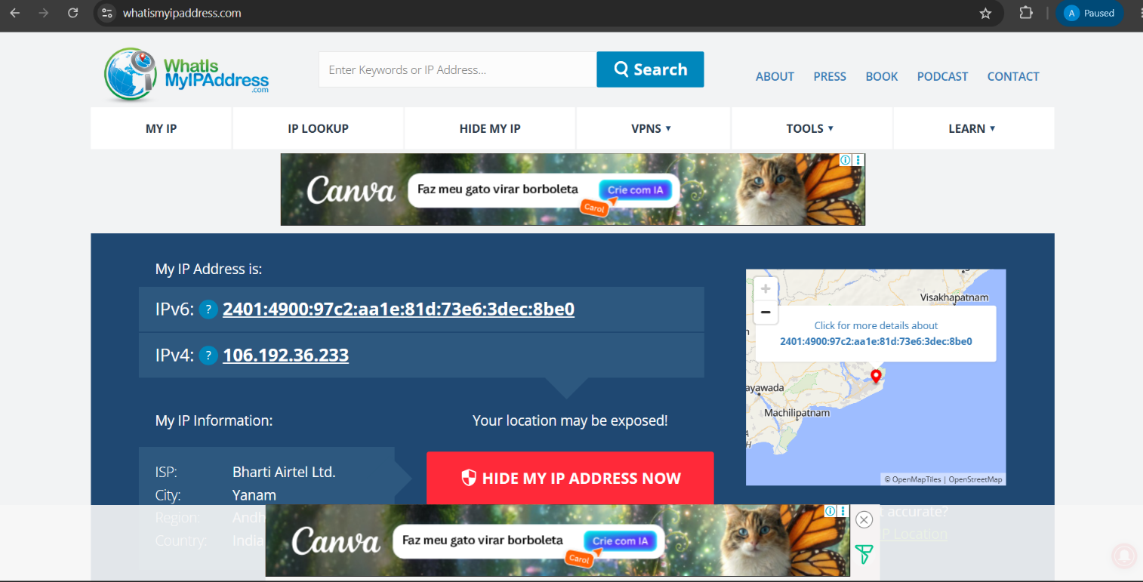

- Ping command output
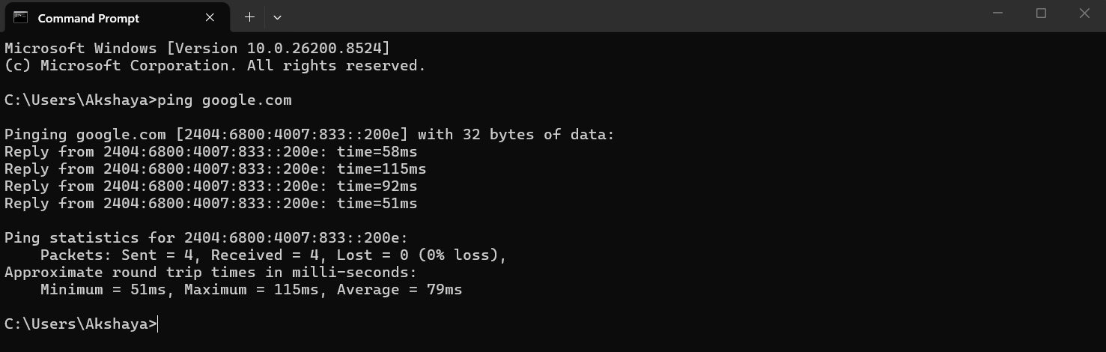

- DNS lookup output
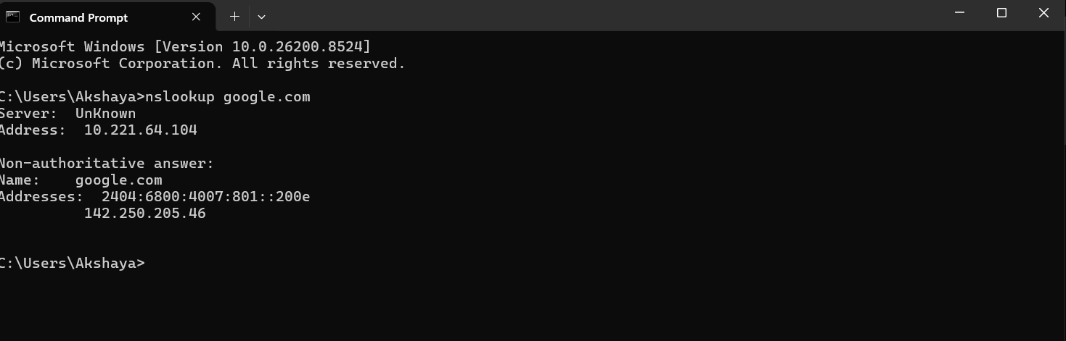

- NAT flow/network diagram
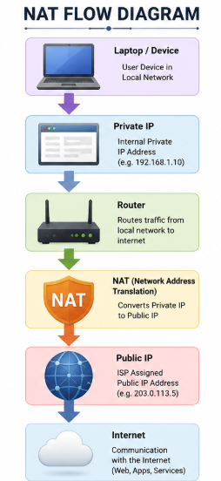

🏆 Key Learning Outcome
Through this project, I learned:
- Difference between public and private IP addresses
- NAT communication flow
- DNS resolution process
- Enterprise networking concepts
- IAM security mapping using IP addresses
- Conditional access and geo-location security concepts
This project strengthened my foundational skills in:
- Networking
- Cybersecurity
- IAM
- Cloud Security
- Security Operations

